MIDN McKenzie Eshleman

221938

SY303 3321

Project 1: Gate Diagrams

1. DMux

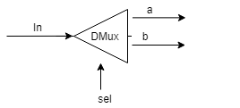

1. Not16

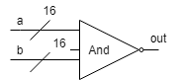

1. And16

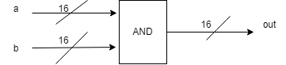

1. Or8Way

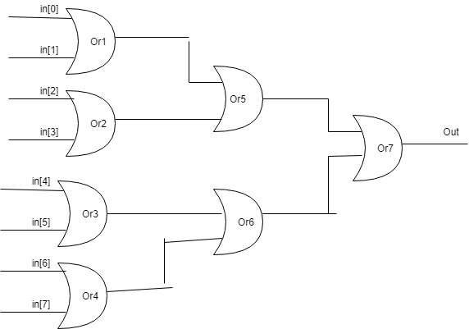

1. Mux16

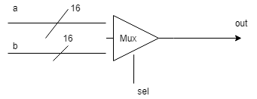

1. Mux4Way16

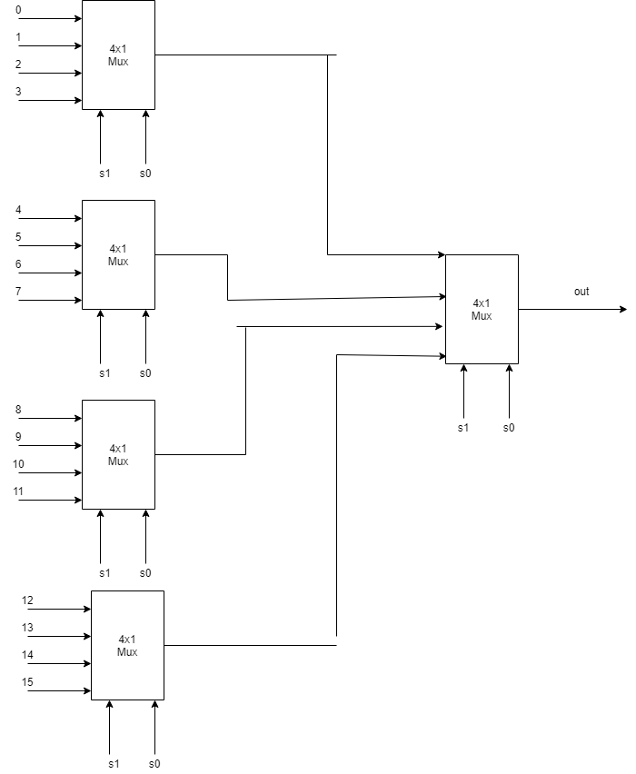

1. DMux4Way

